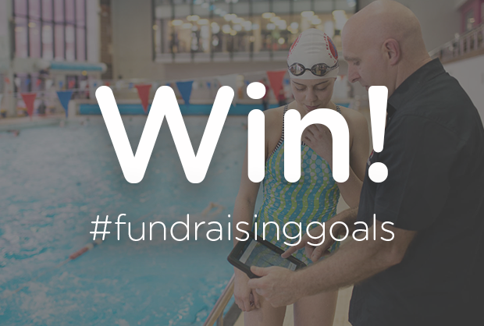

To be in with the chance to a £100 worth of aquatic kit for club or squad, all you need to do is either:

- Register your club or squad as a cause with easyfundraising between 24th September 2018 and 26th October 2018
- If your aquatic club or squad is already registered with easyfundraising, collect at least one donation between 24th September 2018 and 26th October 2018

Terms & Conditions
- No purchase necessary.
- The competition is open to all aquatic clubs & squads registered as an easyfundraising cause
- The competition will run from 24th September 2018 to 26th October 2018.
- Last time for entry will be 23:59, 26th October 2018.
- New clubs or squad who register as an easyfundraising cause between 24th September 2018 and 26th October 2018 will be entered into the prize draw.
- Aquatic clubs or squads who registered as an easyfundraising cause prior 24th September 2018 must collect at least one donation in the competition period to be eligible for the draw.
- For any clubs or squad to be eligible, they must be registered as an easyfundraising cause by 26th October 2018. Clubs or squad not registered as an easyfundraising cause by this time will not be entered.
- The draw will take place on 29th October 2018 and the first randomly cause selected will win £100 worth of aquatic kit.
- The administrator of the winning cause will be notified by email within 2 working days of the draw taking place. Please ensure your account details are correct.
- In the event that the winner does not reply to their winning notice within 30 days then the prize will be redrawn and awarded to an alternative winning cause.
- No cash alternative will be offered.
- The winner agrees to participate in press and publicity events, and for their name to be featured on the Swim England’s website, Swim England’s Facebook page and Swim England’s Twitter and Instagram pages, the easyfundraising website, easyfundraising Facebook page and the easyfundraising twitter page.
- The judges' decision is final and no correspondence will be entered into.
- By entering the competition, causes agree to be bound by all competition and site rules.

