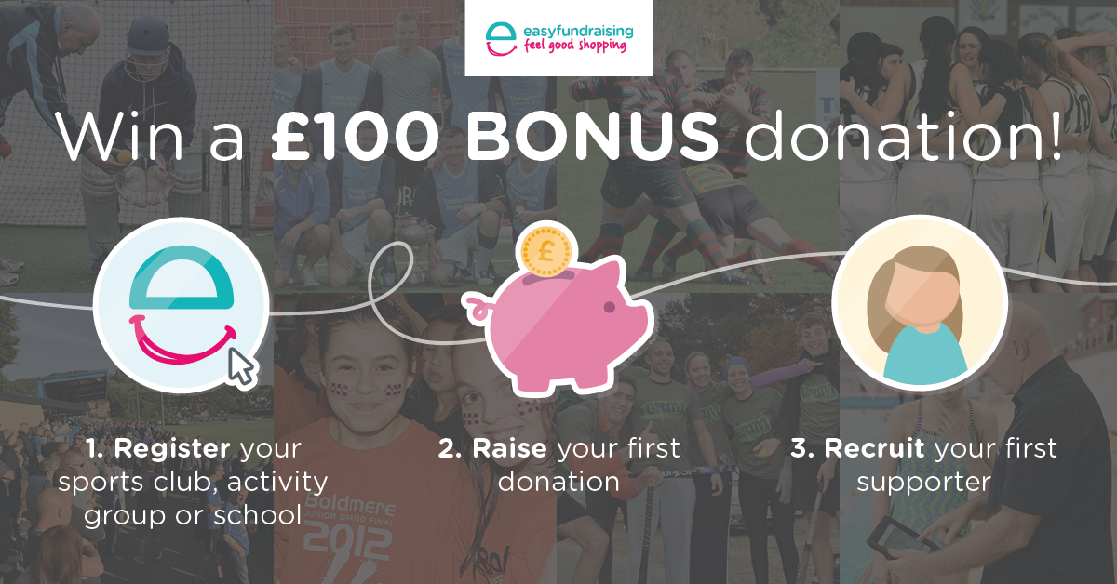
To be in with the chance to win £100 register your sports club, community group or school with easyfundraising, recruit your first supporter and raise your first donation before midnight on Sunday 3rd June 2018.

If your sports club or community group has already registered with easyfundraising, simply recruit one supporter and collect a donation between 07/05/2018 and 03/06/2018 to be entered into the draw.

Terms & Conditions
- No purchase necessary.
- The competition is open to all sports clubs, community groups and schools located within the Active Derbyshire geographical area.
- The competition will run from 07/05/2018 to 03/06/2018.
- Last time for entry will be 23.59, 03/06/2018.
- New sports clubs, community groups and schools who register as an easyfundraising cause, recruit a supporter and raise a donation between 07/05/2018 and 03/06/2018. will be entered into the prize draw.
- Sports clubs & community groups who have already registered with easyfundraising prior to 07/05/2018 must recruit s supporter and collect a donation through the easyfundraising site between 07/05/2018 and 03/06/2018 in order to enter the draw
- For sports clubs, community groups and schools to be eligible, they must be registered with easyfundraising as a cause by 23.59, 03/06/2018. Sports clubs, community groups and schools not registered with easyfundraising as a cause by this time will not be entered.
- The draw will take place on 04/06/2018 and the first randomly selected will win a £100 to support community sport development.
- The administrator of the winning sports club, community group or school will be notified by email within 2 working days of the draw taking place. Please ensure your account details are correct.
- In the event that the winner does not reply to their winning notice within 30 days then the prize will be redrawn and awarded to an alternative winning cause.
- No cash alternative will be offered
- The winner agrees to participate in press and publicity events, and for their name to be featured on the Active Derbyshire website, Active Derbyshire Facebook page and the Active Derbyshire twitter page, the easyfundraising website, easyfundraising Facebook page and the easyfundraising twitter page.
- The Judges' decision is final and no correspondence will be entered into.
- By entering the competition, sports clubs, community groups and schools agree to be bound by all competition and site rules.

